YCC Adds Rip Rap to the Dam
Thank you to the 30 Mile River Watershed Association’s Youth Conservation Corps (YCC) for their adding rip rap to the dam’s spillway. The Youth Conservation Corps’ (YCC) mission is to preserve and improve water quality by addressing erosion and runoff issues on property throughout the watershed. In addition to helping the PPA with its dam maintenance responsibilities, YCC works with homeowners to decrease erosion and filter stormwater carrying phosphorus on their property.

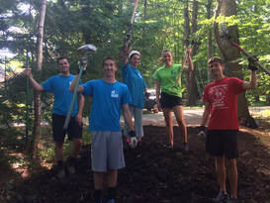
Photo: (L-R) Sebastien Dumont, Austin Gilboe, Lydia Merrick, Rylee Delaney, and Zeke Robinson celebrate a tough job well done!

